**Technical Report: The Study on TB spreading in Singapore: An Agent-based Modeling Approach**

Yao-fei Ma,

Sch. Of Automation Science and Electrical Engineering, Beijing University of Aeronautics and Astronautics, Beijing, China

Jie Zhang,

School of Computer Engineering, Nanyang Technological University, Singapore,

Yin-leng Theng,

Wee Kim Wee School of Communication and Information, Nanyang Technological University, Singapore

ABSTRACT

This paper studies the inﬂuence of migrant workers to Tuberculosis (TB) development in Singapore using the agent-based modeling and simulation approach. We incorporate three novel elements: 1) the non-uniform mixing population caused by different culture backgrounds, job types and spatial distance; 2) a TB transmitting network owns both Scale-Free (power law degree distribution) and Small World characteristics (large clustering coefficient and short average distance); 3) the dynamically changing population of migrant workers and local residents. This model is validated by real data. The simulation results reveal the labor exporting country with the greatest inﬂuence on TB transmitting in Singapore, which is an useful reference for policy decision making.

# INTRODUCTION

Tuberculosis (TB) is an airborne contagious disease. It could be fatal if patients do not receive medical treatment properly. In 2011, about 8.7 million people fell ill with TB, and 1.4 million people died from TB. TB has become a public health challenge not only to developing countries, but also to developed countries like Singapore (Figure 1), U.K. (Public Health England 2013), U.S. (CDC 2013), etc. Actually, in many large cities in these countries, the annual numbers of cases and deaths caused by TB have been increasing since the mid-1980s (Schneider and Castro 2003), even though these countries or cities have very good medical conditions and control policies.

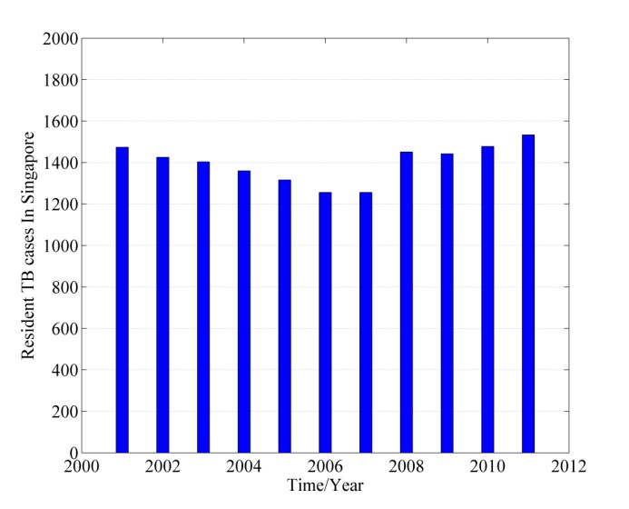

Figure 1. The new active TB cases among residents of Singapore (2001-2011)

An explanation to this phenomenon is that the rapid influx of immigrants, especially those from high TB prevalence countries, imposes their influence to TB development in these developed countries (Kyi et al. 2011; McKenna, McCray and Onorato, 1995; Talbot et al. 2000; Lillebaek et al. 2002; Cain et al. 2008). The studies on the evaluation of this influence have raised wide interests (Lillebaek et al. 2001; Borgdorff et al. 2000; Dahle et al. 2007), especially for Singapore. Singapore is a multi-cultural immigrant society. Its rapid economic growth in recent decades depends heavily on its immigrant population. Compared to other countries, the immigrants in Singapore show 3 characteristics:

1. The population size reached a surprising number of 1.3 million (2013), almost a quarter of the total population;
2. The immigrants are mostly short-term migrant workers. They come and leave frequently, which leads to the difficulties in developing proper TB control policies;
3. Most migrant workers come from several East Asian countries. Some of them are among the highest TB incidence countries ever registered (WHO 2013).

Considering these characteristics, an interesting **Question** is: which labor exporting country has the greatest potential to influence the TB development in Singapore? The answer to this question is important not only to TB situation awareness in this country, but also to the improvement of TB control strategies.

In this paper, an Agent-based Modeling (ABM) approach is employed to explore this question. The main content is organized as follows. Firstly, the related studies on TB transmitting between immigrants and local residents are introduced (Section 2). Then the details of the agent-based model employed in this paper are discussed (Section 3). At last, the validation work is discussed and experiment is conducted to give the final result.

# RELATED WORK

Different approaches/models have been employed in the study of how immigrants influence TB development in their host country.

DNA fingerprint is a biomedical method that can track TB transmitting path by comparing the genes of TB virus. Lillebaek et al. (2001), Borgdorff et al. (2000), Dahle et al. (2007) used DNA fingerprint to find the magnitude of TB transmission between immigrants and local residents in Denmark, U.S., and Sweden. The results showed that the inter transmissions between immigrants and residents are limited in these areas. However, this conclusion cannot be applied to Singapore, considering the huge proportion of immigrants in the total population, as well as the characteristic of quick flowing. Weis et al. (2001) studied the TB transmission between foreign-born people (including immigrants and nonimmigrant visitors) and local born people, finding the nonimmigrant visitors to be an important source of tuberculosis. In spite of high accuracy of this approach, it is difficult to study big group because of its high cost.

A widely used mathematic approach is SIR model and its extended versions (Kermack and McKendrick, 1932; Bailey 1957; Anderson and May, 1992). SIR model uses differential equations to describe disease transmission between compartmental groups with different disease status, such as Susceptible, Infected, and Recovery. Jia et al. (2008) studied TB transmission between immigrants and resident people using SIR model. The TB transmitting happened inside and between immigrants and resident people is modeled by two set of SIR equations respectively. Zhou et al. (2008) studied TB transmission in Canadian-born and foreign-born populations, and found out that the immigrant LTBI cases have significant influence on the overall TB incidence rate in Canada. However, SIR model has its limitations. The obvious one is that it is difficult to capture the heterogeneous nature of individuals. For example, a default assumption in SIR is that the population is randomly mixed, i.e., each individual has an equal chance to contact with each other. It is not true in the real world. The second is that it is difficult to describe TB transmitting along social network, which is the basic mechanism for infectious diseases to spread. Although Eames et.al. (2008) discussed the integration of social network and SIR model, but the whole system become extremely complex and difficult to resolve.

Recently, ABM approach has received great attention in the study of epidemiology. ABM is a bottom-up (Parunak, Savit and Riolo, 1998) modeling approach in that the individual’s behavior is modeled firstly, and then many individuals together form the macro-system and show the system dynamic. The modelers can build complex interaction systems that are difficult to be described in mathematical equations. ABM is used to predict the spread of infectious disease (Teweldemedhin, Marwala and Mueller, 2004; Amouroux, Desvaux and Drogoul, 2008; Linard et al. 2009), explore the relationships between environments and diseases (Dion, VanSchalkwyk and Lambin, 2011; Auchincloss and Roux, 2008), or help to develop epidemic controlling policies (Barrett et al. 2009; Moore et al. 2009).

Considering the complexity of the problem, we have strong reasons to choose ABM approach in our study. Firstly, the migrant workers in Singapore is a mixture of people from more than 10 countries. These people own different cultural background and languages. Thus the assumption of uniform mixing is unacceptable. TB transmitting between groups defined by nationalities needs to be modeled. Secondly, the initial TB status of different groups also needs to be configured according to parameters of their own home countries. ABM is the best way to incorporate all these complexities and diversities.

# MODELING

As a communicable disease, TB can be thought as spreading on a contact network. However, it is difficult, and not necessary accurately, to build a complete network model that is capable of capturing all aspects of contacts among people. In this section, a network model based on social affinity is proposed. Different social features are captured in the definition of social affinity. Additionally, the TB disease development process, the dynamically changing population of migrant workers and their parameters are also discussed.

## TB Transmitting Network

According to the medical observation (WHO, 2014), TB bacteria spread from person to person in tiny microscopic droplets when an active TB patient coughs, sneezes, speaks, or laughs. Thus the “contact” enables transmission to be defined as fact-to-fact or physical contact, especially those happened in small, confined space, like home, office, vehicles (CDC, 1995; Feske et al. 2011; Read, Eames and Edmunds, 2008). Several factors are considered in the construction of such a network.

Firstly, the topology characteristic of the network. This would help us to validate the resulting network, and to make sure that it owns similar statistical properties as the real one. Recently, Read et al. (2008) and Salathé et al. (2010) use wireless, embedded communication devices to record face-to-face or physical contact with information of participants and contact time. The records show that the underlying contact network exhibits typical small-world properties.

Another factor needed to be considered is the degree distribution. Sun et al. (2013) analyzed the daily encounter pattern from the commute records of 2 million people in Singapore, and showed that the degree distribution between those who regularly meet in bus is basically a power law distribution with an exponential cutoff when degree becomes big. Although commuting is only a small part of human activities, it does reflect the daily routine in people’s life. Boguñá et al. (2004) and Newman, Watts and Strogatz (2002) also obtained the similar conclusions about degree distribution in their studies.

Finally, social affinity is another key factor to describe the network model. Social affinity is defined by the kinship of spirit, common interest and other interpersonal commonalities between people (Mc Connell and James 1999; Godde et al. 2013). Generally, people with close social affinity are more likely to contact with each other. In this paper, social affinity will be modeled as the indicator to the possibility of contact between agents in the network.

### Social Affinity Among Population Groups

Social affinity is a measure of “how close” on social relationship between individuals. Suppose the social affinity is described by factors (thus forming a -dimensional space), we have:

(1)

where is weight factors, and is social affinity along the dimension in the space. According to Boguñá et al. (2004), one formation of could be:

(2)

where is normalized to , and the parameters are:

1. : the ‘distance’ between individuals and along the dimension in space. The computation of will be discussed later.
2. and : deciding the plot shape of . In the -dimension space, multiple and compose the parameter vectors and .

In this paper, three important factors (i.e. dimensions) are considered to describe the social affinity between individuals: culture difference, job type and spatial distance.

* Culture Difference

Culture difference is critical to social affinity between individuals. To model it, the migrant workers in Singapore are divided into groups according to their home countries including: China (including Hong Kong and Macao), Malaysia, India, Indonesia, Philippines, Myanmar, and Bangladesh. These countries are not only the main labor exporting countries to Singapore, but also the top 7 ones that contributed most to new TB cases reported in Singapore. Migrant workers from these countries are denoted a*s*  respectively, and the local residents is denoted as . The “culture difference” between these groups is described by languages and geographical distance between their countries.

Speaking same language means that it is easier to communicate between people, i.e., the closer social affinity. The “culture difference” caused by languages can be computed as follow:

(3)

where and are the maximal and minimum numbers of languages shared by different groups. denotes the number of languages shared by group and . For example, English is the official language both in Singapore and India, thus . If the languages are different but belong to the same family (for example, both Bahasa Indonesia and Filipino belong to the Malayo-Polynesian language family), would be set a value between .

The geographical distance between countries is another indicator for culture difference. If the distance between two countries is short, then their people can exchange more easily, resulting in closer social affinity. Without loss of generality, the distance is represented by flight time between capitals of these countries.

(4)

where is the flight time from country to country , and and are maximal and minimum values among all flight times. Combining two factors together, we get the “distance” function of cultural difference:

(5)

Applying (5) in (2), the social affinity caused by “cultural difference” can be computed, as Fig. 2 shows.

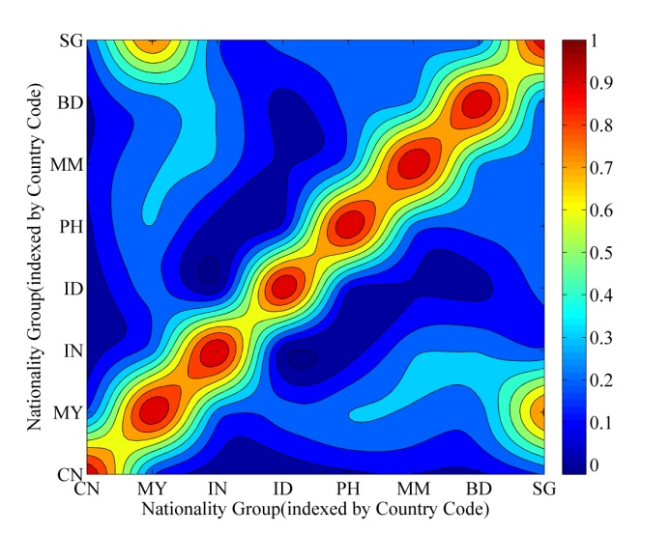

Figure 2. The social affinity caused by “cultural difference” between groups. The parameters values: =0.8*,* =0.2*,* = 0.3*,* = 2

* Job Type

Job type influences the time of coexistence between different people. For example, a “maid” would have closer social affinity to local residents compared to other job types since they have to spend most of their time with the host family. According to the statistic data in (Yue, 2011), three job types are considered here: a) workers in manufacturing and construction business; b) maids; c) service job other than maid, including trade, hotel and restaurant, etc. People in different groups with different job types are indexed by , where is the index of groups, and is the index of job types.

To describe the social affinity associated with job types, a matrix is constructed in that each element is the possible coexistence time length (hour) between and within a single day. For example, a Chinese worker, indexed by , may allocate his/her time in this way: 80% with the co-workers, 19% with service job people, and 1% with maid. Although this estimation is determined empirically, it reflects some intuitions on social affinity caused by job types. We have:

(6)

Applying (6) in (2), the social affinity can be computed.

* Spatial distance

Among all factors of social affinity, spatial distance maybe the most important one. It comes from the fact that for most people, the members within his “social circles” are often close to him in spatial distance, such as coworkers, friends in school, neighbors, etc. The “distance” function of spatial distance is simply the Euclidean distance:

(7)

where and are positions of individual and. Applying (7) in (2), the social affinity can be computed.

Combining above three factors, the final social affinity is:

(8)

where . It should be noted that (1) is amended here to enable “spatial distance” to influence both the “culture difference” and “job type” factors.

### Degree Distribution of the Network

The degree distribution determines the neighborhood size in a network. According to Sun et al. (2013) and Newman, Watts and Strogatz (2002), for those regularly meet with each other face-to-face (or physically) in their daily routine, the degrees basically follow the power law distribution. This kind of degree distribution is used to describe our TB transmitting network. Eqn. (9) is an approximate function of it:

(9)

where the parameters , and need to be identifies. It is easier to estimate them in log-log coordinates, as Figure 3 shows: is the slope of the linear part, , and can be computed by Eqn. (10):

1 (10)

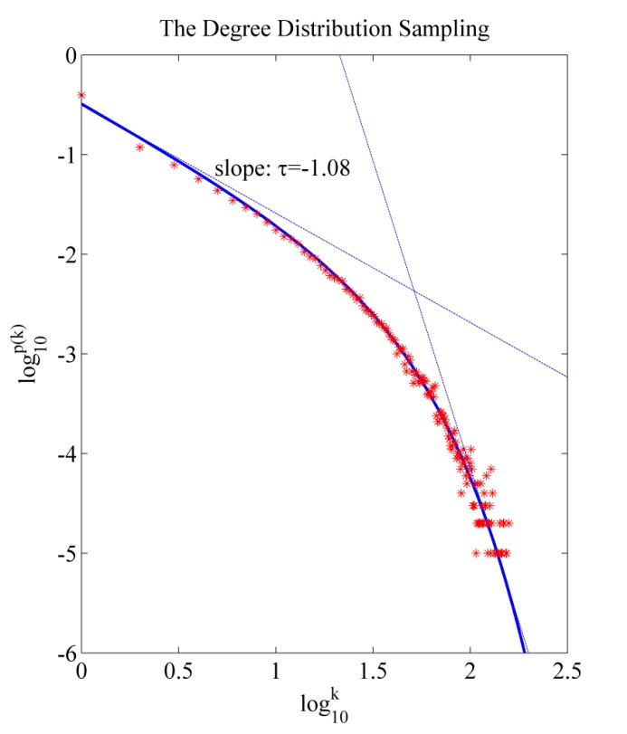

Figure 3. The degree distribution of Eqn. (9). The asterisks are degree samples. The plot follows power law when is small, and has an exponential cutoff when becomes large. The parameters are estimated as: 1.08, 0.3342, 27.

### Network Construction Algorithm

In the construction of TB network, the agents are created firstly. Their properties of nationality, job type and position are assigned by random sampling from real distributions. The social affinity computed between any two agents will be used as the probability of contact existence between them.

For each agent, its neighborhood size is determined firstly by sampling from degree distribution, and then the neighbors are picked up according to the social affinity distribution. There are contact connections between agent and its neighbors. The algorithm is described as following.

**Input:**

1. : the specified Network size. Each agent owns a property vector ;
2. : the distribution on nationality groups;
3. : the distribution on job types;
4. : the distribution on position. Assuming ;
5. : the degree distribution.

**Output:**

1. : the constructed TB network

**Local variables:**

1. : The table that contains all initial agents after their creation.
2. : The table that contains agents whose neighborhood size has reached to , where is the degree sampled from .

**Start：**

1. Create agents, assign their properties by sampling on , and . All agents are put into table initially;
2. Sample degree values on for all agents, denoted as ;
3. For each agent , do:
   1. Compute social affinity between and other agents following Eqn. (8), denoted as . is normalized and used as the probability to build connections between and other agents;
   2. Compute the social affinity distribution over groups: ;
   3. For , do:
      1. Sample once from to get a group index ;
      2. Compute conditional social affinity distribution over job type: ;
      3. Sample once from to get a job type ;
      4. Compute the conditional social affinity distribution over position: ;
      5. Sample from to get a position ;
      6. To find a agent by matching . Assume the index is ;
      7. If agent satisfies: a) it is not agent ’s neighbor yet; b) it owns less than neighbors, then agent is specified as a neighbor of agent , and a connection is built between them. Otherwise, switch to 3.3.1 to re-search the neighbors.
   4. Check each neighbor of agent . If the neighbor’s neighborhood has reached the size of degree, then move it from table to table ;
   5. Move agent from to . Continue neighborhood sampling for agent ;
4. return the close table T;

**End**

The network degree distribution follows the power law, which implies that the network is more of a scale-free one. However, the resulting network shows typical small world characteristics, which can be verified by two properties (Wang and Chen, 2003): the clustering coefficient (denoted as ), and the average path length (denoted as ).

We construct different sized networks to compute and , as Figure 4 shows. The value of changes following a power plot. When network size approaches to 5 million (i.e., the total population of Singapore), . It is a big value for , indicating the case “my friends are also friends with each other” exists everywhere. It is a characteristic of a small world network.

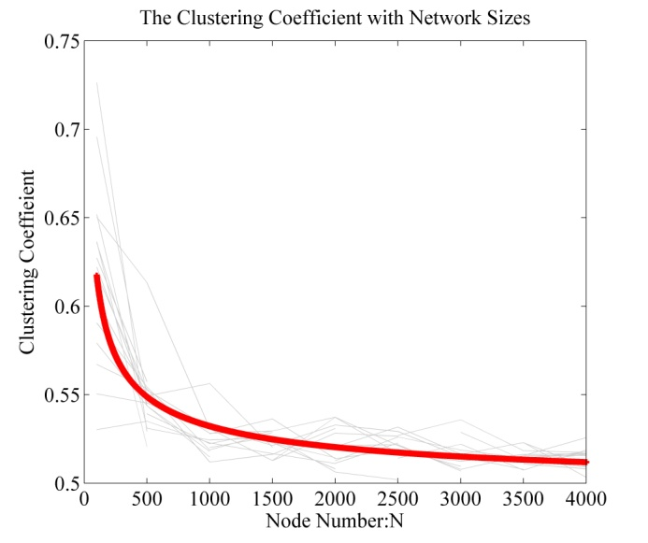

Figure 4. The clustering coefficient with different network sizes. Each size is simulated for 20 rounds, and the result is fitted as a power plot:, where =1.17, =-0.4825, =0.4905.

The average path length , also changes following a power plot, as shown in Figure 5. We can predict when network size approaches to 5 millions. This means that any node in this network can reach to another quickly, which is also a characteristic of a small-world network.

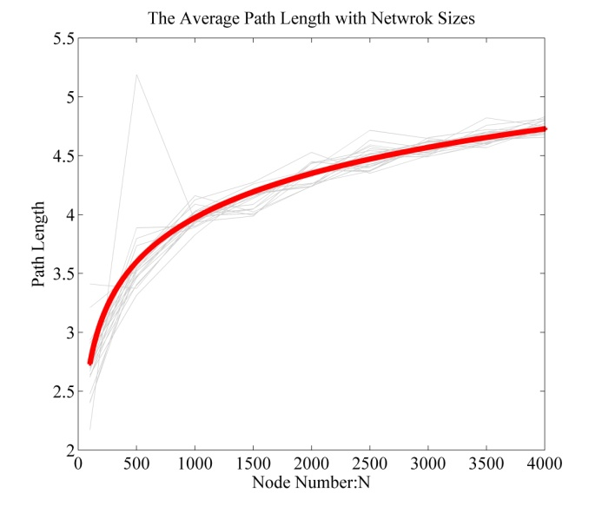

Figure 5. The average path length. The data is also fitted as a power plot: , where =60.85, =-0.008396, =-60.51.

## The State Transferring of TB disease

There are two kinds of TB cases according to whether showing symptoms: the Latent TB, and the active TB. The former has no symptoms, and is not contagious either. The latter can be transformed from the former type, shows explicit symptoms, and is contagious. The development from a healthy people to active TB patient will undergo several states (Aparicio and Castillo-Chavez, 2009), as Figure 6 shows.



Figure 6. The state transferring process of TB disease

State represents people of TB susceptible. When got infected (with probability ), the susceptible will experience two stages: a) the first 5 years since infection (state ), and b) the Latent TB stage () where infection time 5 years. In both stages, there are risks for people to progress to active TB. In state, the risk () is high but exponentially declines with time. In state, the risk () will be at a low level and almost unchanged. As a result, the infected people will be firstly moved into state , and stay there for 5 years. During this period, they either progress to active TB, or become Latent TB.

Although the risk is low, individuals at stage still have a chance to become active TB for many reasons, for example, weak immunity caused by ages or other diseases (endogenous reason), or being exposed to active TB and getting re-infection (exogenous reason). The former is described by arrow from to or , with probability . The latter is described by arrow from to , with probability , which is the same as the probability of infecting a susceptible. From state , the individuals may further become active TB with probability .

The active TB can be classified as pulmonary TB () and extra-pulmonary TB (). Pulmonary TB is infectious and extra-pulmonary is not. The percentage of pulmonary TB among all active TBs is denoted as , which takes different values in different countries. For example, 85% in Singapore, 96% in China. It is reasonable to use and to describe the proportion of active TBs who enter into and respectively.

or individuals may be reported to medical systems with probability to receive medical treatment (state ). The recovery probability is . For TB disease, it is difficult to confirm if the bacteria is completely gone even the patients get recovered. So the recovery individuals would go back to state , indicating that the TB bacteria persists in an immunologically-controlled state.

The mortality is considered in this process. The per capital natural death rate is , and the per capital TB induced death rate is . When the individuals are , and , the death rate will follow , otherwise, follow .

The new incoming migrant workers will initially fell into 4 possible states: , , , and . These initial states are determined by parameters , and . Their descriptions can be found in Table 1.

Table 1. The Parameters List

|  |  |
| --- | --- |
| Parameters | Description |
|  | The infecting probability per unit time. See **Section 3.3** |
|  | The probability of progression to active TB in the first 5 years since infection. See **Section 3.3.** |
|  | The probability to become Latent TB from state. if time <5 years since infection; otherwise,; |
|  | The probability to progress to active TB from Latent TB (state) for endogenous reasons; |
|  | The percentage of pulmonary TB among all active TB cases†; |
|  | The prevalence of active TB in the new incoming population†.  It should be noted that Singapore requests all migrant workers to take chest radiographic test before entering. According to Kumar et al. (2004), Ito (2005), Cleeff et al. (2005), Arslan et al. (2010), and Waitt et al. (2013), the chest radiographs have a sensitivity about 75%-80% (denoted as ) in detecting active TB. As a result, ; |
|  | the prevalence of latent TB in the new incoming population. WHO’s estimate is about 0.33; |
|  | the percentage of susceptible in the new incoming population. ; |
|  | The probability of being reported to the medical system and receive medical treatment; |
|  | The per capital natural death rate†; |
|  | The per capital TB induced death rate†; |
|  | The recovery rate after receiving treatment†; |

†: the data comes from the WHO global TB database.

## TB Transmitting Parameters

The key parameters of TB transmitting are and (Figure 6). is the infecting probability per unit time, which can be evaluated according to reproductive number , whose value is about 7~15 (WHO 2013; Tian and Osgood 2013) for TB disease, i.e., an active TB would infect 7~15 people each year when surrounded by susceptible.

Denoting as the size of neighborhood for any agent, we have: . In our network, the value of is sampled from degree distribution, then can be computed consequently. It is consistent with our intuition that is inversely proportional to : if a person has a large neighborhood, the average time in contact with each neighbor would be short, thus the transmitting risk per unit time would be low.

is the probability of progression to active TB from initial infection. Empirical observations (Aparicio and Castillo-Chavez 2009; Vynnycky 2013; Tian 2013) show that about 60% progressions happened in the 1st year since infection, and above 95% progressions happen within the first 5 years. An TB observation trial (Vynnycky 2013; Girling et al. 1988) conducted during the 1950s proposed more details about this data, as Figure 7 shows.

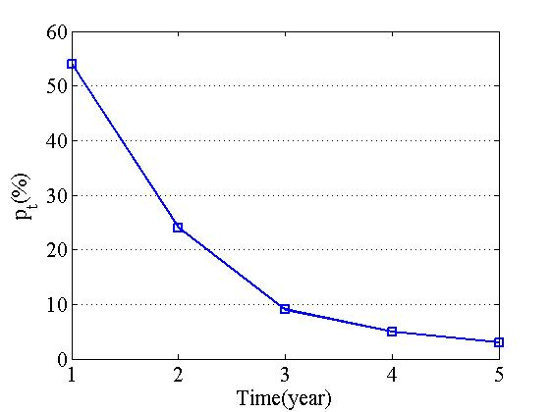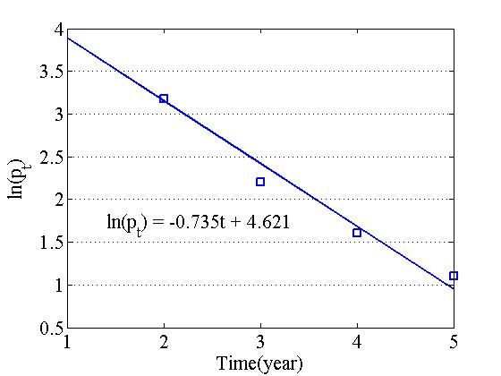

Figure.7. The risk of progression to active TB in the first 5 year since infection: i) The trend of . About 60% progression to active TB happened in the 1st year since infection, and about 95% happened in the first 5 years since infection. ii) The can be linearized fitted, which means follows exponential law.

It shows that the progression risk exponentially decays in the first 5 years since infection, and then keeps at a very low level. From Figure 6(b), a fitting function of is:

(11)

According to Tian (2013), an infected person has 14.7% chance to become active TB throughout his or her life (50 years). Assuming that the progression risk keep constant after 5 years since infection, we have:

(12)

where and are the progression probabilities of the 1st and 6th year since infection, respectively. Once is determined using Eqn. (12), the value of of each year can be computed by Eqn. (11).

## The Dynamic Changes of Population

The amount of migrant workers in Singapore changes frequently. For each year, there are many new incomings to this country, and many leavings at the same time. Some of migrant workers may gain the citizenship and become Permanent Residents (PRs). The TB control policies applied to migrant workers and citizens are different. For example, if the migrant worker is found to be TB, he/she would be sent back to his/her home country immediately. On the contrary, if the citizens (PRs and Citizens) are infected, they can receive medical treatment with the assistant of the government. To reflect this fact in simulation, the population dynamics is modeled as following.



Figure 8. The population change process chart

We have:

(13.1)

(13.2)

where is the current population of migrant workers, is annual increment of . is the current population of residents (PRs and Citizens), and is annual increment of it. is annual increment of total population.

In (13), , , and are not known, , , and can be found in STATISTICS SINGAPORE (2014). To solve three variables with two equations, we assume the average working pass period is years, then: . For example, means about 20% of total migrant workers would leave annually. By this way , and can be computed.

Considering the multiple nationality groups (), we have: , where is the population of the group. There is limited data about in public domain since the government regards such data as sensitive. We can only find some clues in related research studies (Table 2~Table 9 in Appendix A). The missing data would take values of those we have found.

# Simulatoin and analysis

## Model Validation

Two experiments are conducted to validate the model described above. The first one explored the relationship between new active TB cases produced (per year) in simulation and the network size. The result is shown in Fig. 9.



Figure 9. the number of new Active TB cases in simulation with respect to simulation size

In Figure 9, each dash line represents the new TBs produced in a specified year between 2000-2011. The values change with population size. The fitting plot of these data is linear (the solid line), which means the produced TB number is proportional to simulation size. This observation enables us to predict the number of new TBs in a large population size (for example, the total 5 million people in Singapore) by running small sized simulations.

Based on the linear relationship, a TB transmitting network containing 22,943 agents is constructed (using AnyLogic 7.0, Evaluation Version) in the second experiment. The TB development in Singapore during 2000-2011 is simulated. The results are compared with the real data. Actually, only two sets of real data about TB can be found in the public domain (MOH 2012): a) the annual number of new TB cases in residents (PRs and citizens); b) the ratios of residential TB among all active TB cases during 2000-2009.

The first graph in Fig. 10 displays the number of new TB cases in residents. The simulation plot (with circle marker) is the average of multiple simulation results. As we can see, it is close to the real data (with square marker), and the dynamics revealed in real data is captured by simulation. The similarity between two plots is measured by the Pearson correlation coefficient, which is +0.561. The second graph displays the ratios of residential TB cases during 2000-2011. The real data is only available from 2000 to 2009. In this period, the Pearson correlation coefficient is +0.825.

Positive correlation coefficients indicate that the simulation results can closely reflect the trend of real data. Even the values are not so “strong” (i.e., <0.9), it still gives us confidence about this model, considering the enormous number of factors that can influence the final outcome.



Figure 10. The compare between simulation and real data: i) the number of active TB cases in Singapore residents (the upper figure) and ii) the ratio of resident active TBs among all active TB cases.

## Result Analysis

Our question is: which labor exporting country owns the greatest potential to influence the TB status in Singapore? To answer it, we change the ratio of each nationality group (denoted as ) in the entire population of migrant workers, and observe the changing rate of active TB cases. For example, the percentage of Chinese workers is , thus the population of China group is. The other six groups would average the rest part and each owns. To test the influence of Chinese workers, would be set to 0.1, 0.2,…1.0. For each value, the cumulative number of new active TBs will be recorded to reflect the changing ratio.

The results are shown in Figure 11. A relative ratio is defined to present the changing rate. Suppose is the number of new active TBs produced with . Then the series value of would be: , , …, .

As we can see, Philippines and Myanmar are the top 2 countries which would promote the generation of more active TBs when their percentages increase in the total population. The larger slope of the trend lines indicates the rapid increasing of new TB cases.

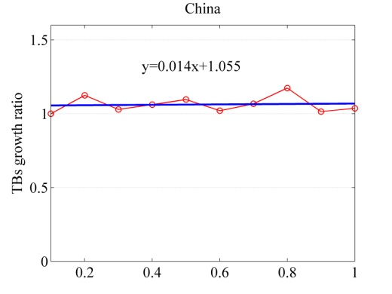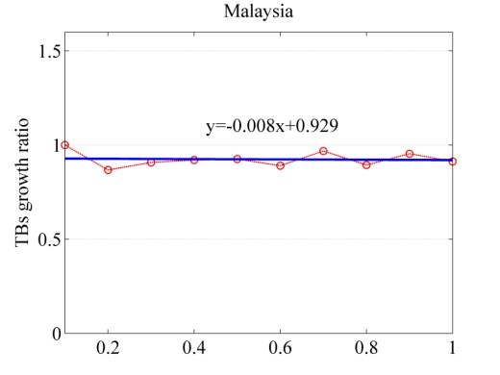

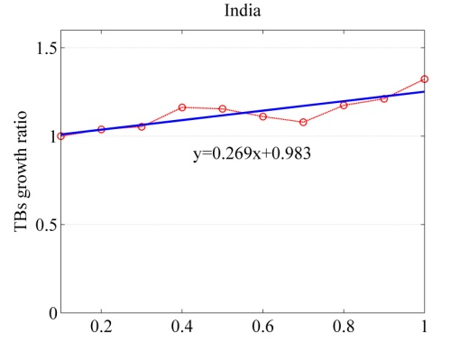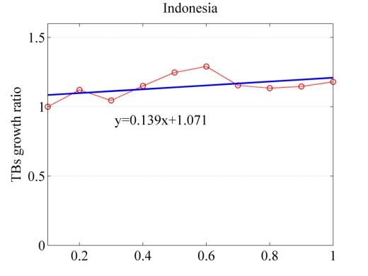

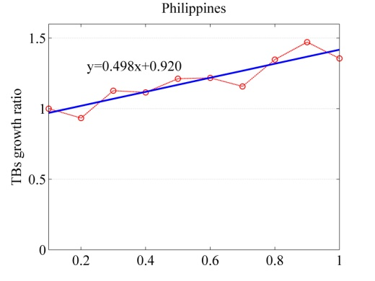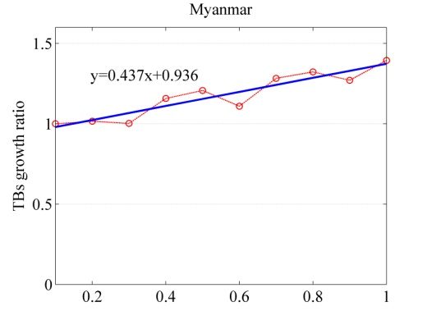

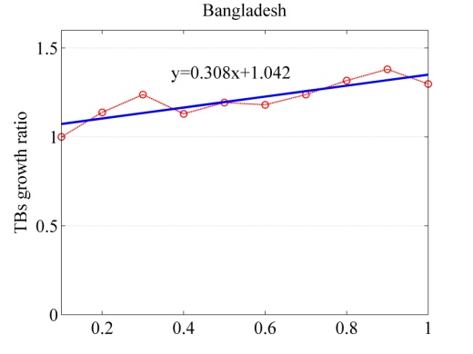

Figure 11. The growth ratio of new TB cases when population of specified group increase

# CONCLUSION and Future Work

In this paper, an ABM approach is applied to study the TB spreading in Singapore from the aspect of migrant worker. A contact network based on social affinity is defined, in that several social features is captured to disguise the possibility of contact between individuals. The TB disease development process is presented; the difference on infection probability in the first 5 year since infection and the following years after that is noticed. Additionally, the population changes of migrant workers are described in our model. The experiment shows that the proposed model can capture the dynamics of TB spreading in Singapore, in that the simulation data fits the statistical data of real-world well.

The ABM approach is suitable to construct a system driven by individual interactions. To some extent, there are only two constraints to this approach: 1) the accurateness of parameters; 2) and the computation power. The former is more critical. The proposed model in this paper still needs to be improved since many of its parameters are just roughly estimated. Additionally, this agent system is still largely an average model, i.e., not heterogeneous enough. For example, the degree in a real world social network cannot be a constant number. It can vary much depending on the living environment, job type, and even personality. Another drawback is that some social activities related with TB control are not modeled, for example, the TB elimination activities supported by the government, or prevention measures like contact tracing when new TB cases is found. In the future, these factors would be further modeled to improve the reliability of the model.

# ACKNOWLEDGMENTS

This research is supported by the Singapore National Foundation under its International Research Centre @ Singapore Funding Initiative and administered by the IDM Programme Office.

1. APPENDICES

The TB parameters for each nationality group need to be configured separately. They are listed in following tables.

Table 2. The TB Parameters of Malaysia

|  |  |  |
| --- | --- | --- |
| **Parameters** | **Value** | **Description** |
|  | 200,000 (2011) | The total number of Chinese workers in Singapore at year .  In 2011, this value is about 200000, and the total number of migrant workers that year is about 1197900. So we can get the ratio 200000/11979000.16696. For missing data, we simply set , where is the total Chinese workers in Singapore at year . |
|  | Computed in simulation | The leaving number at year . Supposing the average work contact time length is years, then about of workers would leave annually, i.e., . =5 in the simulation. |
|  | Computed in simulation | The incoming number of migrant workers from Malaysia at year . |
|  | 33.3% | The prevalence of latent TB in China. The estimated value by WHO is 1/3. |
|  | 0.133% | The prevalence of active TB in China. |
|  | 96.43% | The percentage of pulmonary TB among all active TB cases in China. |
|  |  | The percentage of susceptible in China population. |
|  | 0.731% | The natural death rate in China. |

Table 3. The TB Parameters of Malaysia

|  |  |  |
| --- | --- | --- |
| **Parameters** | **Value** | **Description** |
|  | 214,000 (2011) | The total number of Malaysia workers in Singapore at year . |
|  | Computed in simulation | The leaving number at year . |
|  | Computed in simulation | The incoming number of migrant workers from Malaysia at year . |
|  | 33.3% | The prevalence of latent TB in Malaysia. The estimated value by WHO is 1/3. |
|  | 0.1175% | The prevalence of active TB in Malaysia. |
|  | 87.97% | The percentage of pulmonary TB among all active TB cases. |
|  |  | The percentage of susceptible in population. |
|  | 0.497% | The natural death rate in Malaysia. |
|  | 0.006155% | The death rate caused by TB disease. |

Table 4. The TB Parameters of India

|  |  |  |
| --- | --- | --- |
| **Parameters** | **Value** | **Description** |
|  | 200,000 (2011) | The total number of Indian workers in Singapore at year . |
|  | Computed in simulation | The leaving number of Indian worker at year |
|  | Computed in simulation | The incoming Indian workers at year . |
|  | 33.3% | The prevalence of latent TB in India. |
|  | 0.3435% | The prevalence of active TB in India. |
|  | 84.28% | The percentage of pulmonary TB among all active TB cases. |
|  |  | The percentage of susceptible in population. |
|  | 0.739% | The natural death rate of India. |
|  | 0.03336% | The death rate caused by TB disease in India. |

Table 5. The TB Parameters of Indonesia

|  |  |  |
| --- | --- | --- |
| **Parameters** | **Value** | **Description** |
|  | 100,000 (2011) | The total number of Indonesian workers in Singapore at year . |
|  | Computed in simulation | The leaving number of Indonesian worker at year |
|  | Computed in simulation | The incoming Indonesian workers at year . |
|  | 33.3% | The prevalence of latent TB in Indonesia. |
|  | 0.3426% | The prevalence of active TB in Indonesia. |
|  | 97.1% | The percentage of pulmonary TB among all active TB cases. |
|  |  | The percentage of susceptible in population. |
|  | 0.631% | The natural death rate of Indonesia. |
|  | 0.03655% | The death rate caused by TB disease in Indonesia. |

Table 6. The TB Parameters of Philippines

|  |  |  |
| --- | --- | --- |
| **Parameters** | **Value** | **Description** |
|  | 180,000 (2011) | The total number of Philippine workers in Singapore at year . |
|  | Computed in simulation | The leaving number of Philippine worker at year |
|  | Computed in simulation | The incoming Philippine workers at year . |
|  | 33.3% | The prevalence of latent TB in Philippines. |
|  | 0.608% | The prevalence of active TB in Philippines. |
|  | 98.73% | The proportion of pulmonary TB among all active TB cases in Philippines. |
|  |  | The percentage of susceptible in population. |
|  | 0.495% | The natural death rate of Philippines. |
|  | 0.03427% | The death rate caused by TB disease in Philippines. |

Table 7. The TB Parameters of Myanmar

|  |  |  |
| --- | --- | --- |
| **Parameters** | **Value** | **Description** |
|  | 100,000 (2011) | The total number of Myanmar workers in Singapore at year . |
|  | Computed in simulation | The leaving number of Myanmar worker at year |
|  | Computed in simulation | The incoming Myanmar workers at year . |
|  | 33.3% | The prevalence of latent TB in Myanmar. |
|  | 0.6309% | The prevalence of active TB in Myanmar. |
|  | 75.28% | The percentage of pulmonary TB among all active TB cases in Myanmar. |
|  |  | The percentage of susceptible in population of Myanmar. |
|  | 0.849% | The natural death rate in Myanmar. |
|  | 0.06546% | The death rate caused by TB disease in Myanmar. |

Table 8. The TB Parameters of Bangladesh

|  |  |  |
| --- | --- | --- |
| **Parameters** | **value** | **Description** |
|  | 90,000 (2011) | The total number of Bangladesh workers in Singapore at year . |
|  | Computed in simulation | The leaving number of Bangladesh worker at year |
|  | Computed in simulation | The incoming Bangladesh workers at year . |
|  | 33.3% | The prevalence of latent TB in Bangladesh. |
|  | 0.439% | The prevalence of active TB in Bangladesh. |
|  | 88.67% | The percentage of pulmonary TB among all active TB cases in Bangladesh. |
|  |  | The percentage of susceptible in population. |
|  | 0.567% | The natural death rate in Bangladesh. |
|  | 0.05009% | The death rate caused by TB in Bangladesh. |

Table 9. The TB Parameters of Singapore Residents

|  |  |  |
| --- | --- | --- |
| **Parameters** | **value** | **Description** |
|  | 33.3% | The prevalence of latent TB in Singapore. |
|  | 0.04791% | The prevalence of active TB in Singapore. |
|  | 85.95% | The proportion of pulmonary TB among all active TB cases in Singapore. |
|  |  | The percentage of susceptible in population. |
|  | 0.341% | The average natural death rate in Singapore. |
|  | 0.002336% | The average death rate caused by TB in Singapore. |

# references

Public Health England. “Tuberculosis in the UK: 2013 report.” Public Health England, 2013.

Centers for Disease Control and Prevention (CDC). “Trends in tuberculosis-United States, 2012. ” MMWR. Morbidity and mortality weekly report 62 (2013): 201.

Schneider, E., and K. G. Castro. “Tuberculosis trends in the United States, 1992–2001.” Tuberculosis 83, no. 1 (2003): 21-29.

Win, Khin Mar Kyi, Cynthia BE Chee, Liang Shen, Yee T. Wang, and Jeffery Cutter. “Tuberculosis among foreign-born persons, Singapore, 2000–2009.” Emerging infectious diseases 17, no. 3 (2011): 517.

McKenna, Matthew T., Eugene McCray, and Ida Onorato. “The epidemiology of tuberculosis among foreign-born persons in the United States, 1986 to 1993.” New England Journal of Medicine 332, no. 16 (1995): 1071-1076.

Talbot, Elizabeth A., Marisa Moore, Eugene McCray, and Nancy J. Binkin. “Tuberculosis among foreign-born persons in the United States, 1993-1998.” Jama 284, no. 22 (2000): 2894-2900.

Lillebaek, Troels, Ase B. Andersen, Asger Dirksen, Else Smith, Lene T. Skovgaard, and Axel Kok-Jensen. “Persistent high incidence of tuberculosis in immigrants in a low-incidence country. ” Emerging infectious diseases 8, no. 7 (2002): 679-684.

Cain, Kevin P., Stephen R. Benoit, Carla A. Winston, and William R. Mac Kenzie. “Tuberculosis among foreign-born persons in the United States. ” Jama300, no. 4 (2008): 405-412.

Lillebaek, Troels, Ase B. Andersen, Jeanett Bauer, Asger Dirksen, Steffen Glismann, Petra de Haas, and Axel Kok-Jensen. “Risk of Mycobacterium tuberculosis transmission in a low-incidence country due to immigration from high-incidence areas.” *Journal of clinical microbiology* 39, no. 3 (2001): 855-861.

Borgdorff, M. W., M. A. Behr, N. J. D. Nagelkerke, P. C. Hopewell, and P. M. Small. “Transmission of tuberculosis in San Francisco and its association with immigration and ethnicity.” *The International Journal of Tuberculosis and Lung Disease* 4, no. 4 (2000): 287-294.

Dahle, Ulf R., Vegard Eldholm, Brita A. Winje, Turid Mannsåker, and Einar Heldal. “Impact of immigration on the molecular epidemiology of Mycobacterium tuberculosis in a low-incidence country.” *American journal of respiratory and critical care medicine* 176, no. 9 (2007): 930-935.

World Health Organization (WHO). Global tuberculosis report 2013. World Health Organization, 2013.

Weis, Stephen E., Patrick K. Moonan, Janice M. Pogoda, L. E. Turk, Barbara King, Sherry Freeman-Thompson, and Gerry Burgess. “Tuberculosis in the foreign-born population of Tarrant county, Texas by immigration status.” *American journal of respiratory and critical care medicine* 164, no. 6 (2001): 953-957.

Kermack, William O., and Anderson G. McKendrick. “Contributions to the mathematical theory of epidemics. II. The problem of endemicity.” *Proceedings of the Royal society of London*. Series A 138, no. 834 (1932): 55-83.

Bailey, Norman Thomas John. *The mathematical theory of epidemics*. London, 1957.

Anderson, Roy M., Robert M. May, and B. Anderson. *Infectious diseases of humans: dynamics and control*. Vol. 28. Oxford: Oxford university press, 1992.

Jia, Zhong-Wei, Gong-You Tang, Zhen Jin, Christopher Dye, Sake J. Vlas, Xiao-Wen Li, Dan Feng, Li-Qun Fang, Wen-Juan Zhao, and Wu-Chun Cao. “Modeling the impact of immigration on the epidemiology of tuberculosis.” *Theoretical population biology* 73, no. 3 (2008): 437-448.

Zhou, Yicang, Kamran Khan, Zhilan Feng, and Jianhong Wu. “Projection of tuberculosis incidence with increasing immigration trends.” *Journal of theoretical biology* 254, no. 2 (2008): 215-228.

Eames, Ken TD, and Matt J. Keeling. “Modeling dynamic and network heterogeneities in the spread of sexually transmitted diseases.” *Proceedings of the National Academy of Sciences* 99, no. 20 (2002): 13330-13335.

Parunak, H. Van Dyke, Robert Savit, and Rick L. Riolo. “Agent-based modeling vs. equation-based modeling: A case study and users’ guide.” In *Multi-agent systems and agent-based simulation*, pp. 10-25. Springer Berlin Heidelberg, 1998.

Teweldemedhin, Eyob, Tshilidzi Marwala, and Conrad Mueller. “Agent-based modelling: a case study in HIV epidemic.” In *Hybrid Intelligent Systems, 2004. HIS'04. Fourth International Conference on*, pp. 154-159. IEEE, 2004.

Amouroux, Edouard, Stéphanie Desvaux, and Alexis Drogoul. “Towards virtual epidemiology: an agent-based approach to the modeling of H5N1 propagation and persistence in North-Vietnam.” In *Intelligent agents and multi-agent systems*, pp. 26-33. Springer Berlin Heidelberg, 2008.

Linard, Catherine, Nicolas Ponçon, Didier Fontenille, and Eric F. Lambin. “A multi-agent simulation to assess the risk of malaria re-emergence in southern France.” *Ecological Modelling* 220, no. 2 (2009): 160-174.

Dion, Elise, Louis VanSchalkwyk, and Eric F. Lambin. “The landscape epidemiology of foot-and-mouth disease in South Africa: A spatially explicit multi-agent simulation.” *Ecological Modelling* 222, no. 13 (2011): 2059-2072.

Auchincloss, Amy H., and Ana V. Diez Roux. “A new tool for epidemiology: the usefulness of dynamic-agent models in understanding place effects on health.” *American journal of epidemiology* 168, no. 1 (2008): 1-8.

Barrett, Christopher L., Keith R. Bisset, Jonathan Leidig, Achla Marathe, and Madhav V. Marathe. “Estimating the Impact of Public and Private Strategies for Controlling an Epidemic: A Multi-Agent Approach.” In *IAAI*. 2009.

Moore, David, Anne Dray, Rachael Green, Susan L. Hudson, Rebecca Jenkinson, Christine Siokou, Pascal Perez, Gabriele Bammer, Lisa Maher, and Paul Dietze. “Extending drug ethno‐epidemiology using agent‐based modelling.” *Addiction* 104, no. 12 (2009): 1991-1997.

World Health Organization (WHO), 2014, “Tuberculosis.”, 2014. <http://www.who.int/mediacentre/factsheets/fs104/en/> . [Accessed Feb. 18, 2014]

Centers for Disease Control and Prevention (CDC). “Exposure of passengers and flight crew to Mycobacterium tuberculosis on commercial aircraft, 1992-1995.” *MMWR. Morbidity and mortality weekly report* 44, no. 8 (1995): 137.

Feske, Marsha L., Larry D. Teeter, James M. Musser, and Edward A. Graviss. “Giving TB wheels: Public transportation as a risk factor for tuberculosis transmission.” *Tuberculosis* 91 (2011): S16-S23.

Read, Jonathan M., Ken TD Eames, and W. John Edmunds. “Dynamic social networks and the implications for the spread of infectious disease.” *Journal of The Royal Society Interface* 5, no. 26 (2008): 1001-1007.

Salathé, Marcel, Maria Kazandjieva, Jung Woo Lee, Philip Levis, Marcus W. Feldman, and James H. Jones. “A high-resolution human contact network for infectious disease transmission.” *Proceedings of the National Academy of Sciences* 107, no. 51 (2010): 22020-22025.

Sun, Lijun, Kay W. Axhausen, Der-Horng Lee, and Xianfeng Huang. “Understanding metropolitan patterns of daily encounters.” *Proceedings of the National Academy of Sciences* 110, no. 34 (2013): 13774-13779.

Boguñá, Marián, Romualdo Pastor-Satorras, Albert Díaz-Guilera, and Alex Arenas. “Models of social networks based on social distance attachment.” *Physical Review E* 70, no. 5 (2004): 056122.

Newman, Mark EJ, Duncan J. Watts, and Steven H. Strogatz. “Random graph models of social networks.” *Proceedings of the National Academy of Sciences of the United States of America* 99, no. Suppl 1 (2002): 2566-2572.

Vela-McConnell, James A. *Who is my neighbor?: social affinity in a modern world*. SUNY Press, 1999.

Godde, Sophie, Lionel Humbert, Steeve D. Côté, Denis Réale, and Hal Whitehead. “Correcting for the impact of gregariousness in social network analyses.” *Animal Behaviour* 85, no. 3 (2013): 553-558.

Yue, Chia Siow. *Foreign Labor in Singapore: Trends, Policies, Impacts, and Challenges*. No. DP 2011-24. Philippine Institute for Development Studies, 2011.

Wang, Xiao Fan, and Guanrong Chen. “*Complex networks: small-world, scale-free and beyond.*” Circuits and Systems Magazine, IEEE 3, no. 1 (2003): 6-20.

Aparicio, Juan Pablo, and Carlos Castillo-Chavez. “Mathematical modelling of tuberculosis epidemics.” *Math Biosci Eng* 6, no. 2 (2009): 209-37.

Kumar, N., S. K. Bhargava, C. S. Agrawal, K. George, P. Karki, and D. Baral. “Chest radiographs and their reliability in the diagnosis of tuberculosis.” *JNMA; journal of the Nepal Medical Association* 44, no. 160 (2004): 138-142.

Ito, K. U. N. I. H. I. K. O. “Limits of chest X-ray investigation in the diagnosis of recurrent pulmonary tuberculosis." Kekkaku:[Tuberculosis] 80, no. 7 (2005): 521-526.

Van Cleeff, M. R. A., L. E. Kivihya-Ndugga, H. Meme, J. A. Odhiambo, and P. R. Klatser. “The role and performance of chest X-ray for the diagnosis of tuberculosis: a cost-effectiveness analysis in Nairobi, Kenya.” *BMC infectious diseases* 5, no. 1 (2005): 111.

Arslan, Sulhattin, Levent Ozdemir, Yeltekin Demirel, and Ibrahim Akkurt. “The validity of the diagnostic methods in predicting pulmonary tuberculosis.” *Afr J Microbiol Res* 13 (2010): 613-617.

Waitt, Catriona J., Elizabeth C. Joekes, Natasha Jesudason, Peter I. Waitt, Patrick Goodson, Ganizani Likumbo, Samuel Kampondeni, E. Brian Faragher, and S. Bertel Squire. "The effect of a tuberculosis chest X-ray image reference set on non-expert reader performance." European radiology 23, no. 9 (2013): 2459-2468.

World Health Organization (WHO). Global tuberculosis report 2013. World Health Organization, 2013.

Tian, Yuan, and Nathaniel Osgood. “Comparison between Individual-based and Aggregate Models in the context of Tuberculosis Transmission.” <http://www.systemdynamics.org/conferences/2011/proceed/papers/P1356.pdf> [Accessed October 1, 2013]

Vynnycky, Emilia. “An investigation of the transmission dynamics of M. tuberculosis.” PhD diss., London School of Hygiene & Tropical Medicine, 1996. <http://researchonline.lshtm.ac.uk/682231/> [Accessed November 10, 2013]

Tian, Yuan. “Agent-based modeling and System Dynamics modeling on transmission of Tuberculosis in Saskatchewan.” (2012). <http://ecommons.usask.ca/handle/10388/ETD-2011-10-300> [Accessed October 10, 2013]

Girling, D. J., Janet H. Darbyshire, M. J. Humphries, and Gabriel O'Mahoney. “Extra-pulmonary tuberculosis.” *British medical bulletin* 44, no. 3 (1988): 738-756.

STATISTICS SINGAPORE, 2014, “Population Trends 2013”, 2014, [http://www.singstat.gov.sg](http://www.singstat.gov.sg/publications/publications_and_papers/population_and_population_structure/population2013.pdf) .

MINISTRY OF HEALTH (MOH), 2012, “Number of cases and distribution of tuberculosis infection by site Singapore residents 1960 – 2011”, 2012, <http://www.moh.gov.sg/content/dam/moh_web/PressRoom/Current_Issues/2012/Annex%20-%20World%20TB%20Day%20Press%20Release%2023%20Mar%202012.pdf> .